**Name:**Satyam Kumar Singh **Date:01-03-2023**

**College:**National Institute of Technology Patna,Bihar

**Subject:** Assignment

Q.1 **What is the difference between while and do-while?**

-> **While loop:**

A while loop is a control flow statement that allows code to be executed repeatedly based on a given Boolean condition. The while loop can be thought of as a repeating if statement.  
**Syntax :**

while (boolean condition)

{

loop statements...

}

**Flowchart:**

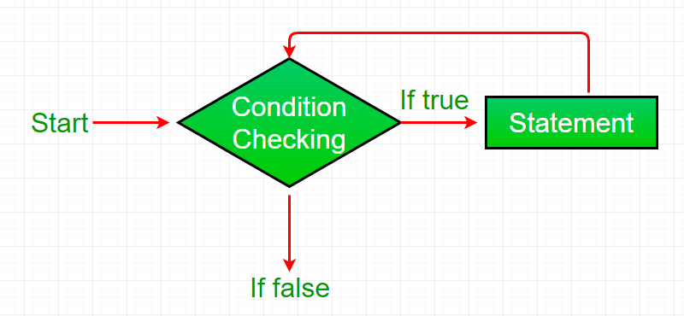

**do-while loop:**do while loop is similar to while loop with the only difference that it checks for the condition after executing the statements, and therefore is an example of **Exit Control Loop.**

**Syntax:**

do

{

statements..

}

while (condition);

**Flowchart:**

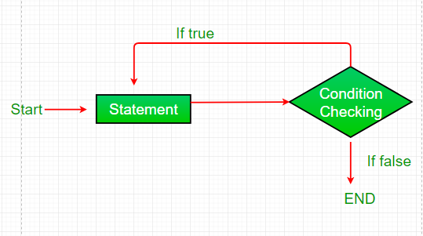

|  |  |
| --- | --- |
| **while** | **do-while** |
| Condition is checked first then statement(s) is executed. | Statement(s) is executed atleast once, thereafter condition is checked. |
| It might occur statement(s) is executed zero times, If condition is false. | At least once the statement(s) is executed. |
| No semicolon at the end of while. while(condition) | Semicolon at the end of while. while(condition); |
| If there is a single statement, brackets are not required. | Brackets are always required. |
| Variable in condition is initialized before the execution of loop. | variable may be initialized before or within the loop. |
| while loop is entry controlled loop. | do-while loop is exit controlled loop. |
| while(condition) { statement(s); } | do { statement(s); } while(condition); |

**Things covered in the class:**

* **Iterative statements:while loop and do-while programming**
* **Functions and its types with examples**

**i.WAP to print 1-10 number using for,while ,do-while:**

console.log("using for loop");

for(let i=1;i<=10;i++){

    console.log(i);

}

console.log("using while loop");

let j=1;

while(j<=10){

    console.log(j);

    j++;

}

console.log("using do while loop");

let k=1;

do{

    console.log(k);

    k++;

}

while(k<=10);

**ii.WAP to print 10 number in reverse order of difference 2(using for,while,do-while):**

console.log("using for loop");

for(let i=20;i>0;i-=2){

    console.log(i);

}

console.log("using while loop");

let j=20;

while(j>0){

    console.log(j);

    j-=2;

}

console.log("using do while loop");

let k=20;

do{

    console.log(k);

    k-=2;

}

while(k>0);

**Functions:**

A function is a set of statements that take inputs, do some specific computation,and produce output. The idea is to put some commonly or repeatedlydone tasks together and make a **function** so that instead of writing the same code again and again for different inputs, we can call the function.  
In simple terms, a function is a block of code that only runs when it is called.

Types of functions:

1.System defined/predefined/built in functions

2.User defined functions:

1. No Argument No Return Type (NANR)
2. No Argument With Return Type (NAWR)
3. With Argument No Return Type (WANR)
4. With Argument With Return Type (WAWR)

Example of NANR Type:

//NO ARGUMENT NO RETURN TYPE FUNCTION

function NANR(){

    console.log("Hello satyam");

    console.log("You are in inside NANR function");

}

NANR();

Example of NAWR Type:

//NO ARGUMENT WITH RETURN TYPE FUNCTION

function NAWR(){

    i+=5;

    return i;

}

let i=6;

console.log(NAWR());

Example of WANR Type:

//WITH ARGUMENT NO RETURN TYPE FUNCTION

function WANR(name){

     console.log("My name is",name);

}

WANR("Satyam");

Example of WAWR Type:

//WITH ARGUMENT WITH RETURN TYPE FUNCTION:

function WAWR(name1,name2){

    let x=name1+" "+name2;

    return x;

}

let fn=WAWR("satyam","singh");

console.log("My name is:",fn);